**Assignment**

1) The number of movies released between 1950 and 1960.

**Query:**

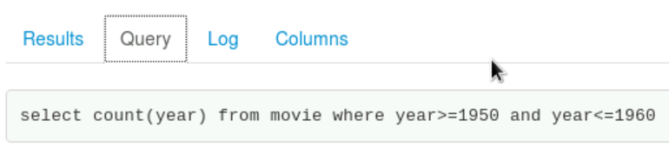

2) The number of movies having rating more than 4.

**Query:**

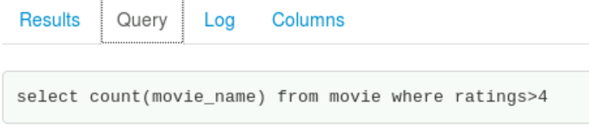

**Output:**

3) The movies whose rating are between 3 and 4.

**Query:**

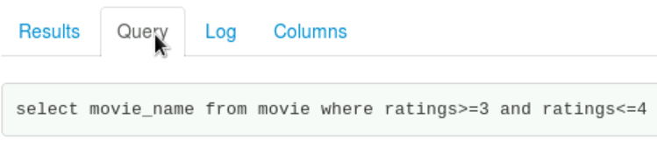

**Output:**

4) The number of movies with reviews more than 7200.

**Query:**

**Output:**

5) The list of years and number of movies released each year.

**Query:**

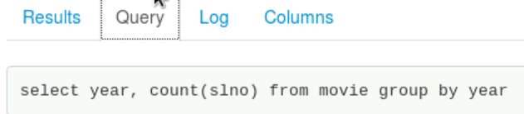

**Output:**

6) Total number of movies in dataset.

**Query:**

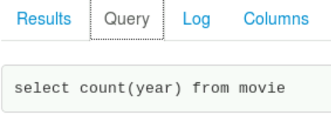

**Output:**

